Please join us for a Great Community Tradition!
66th Annual
1957 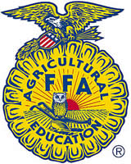 2022
Livestock and Plant Project Show, Parade, BBQ, & Auction
March 31st - April 2nd, 2022
-------------------------------------------------------------------------------
Show, Sale, Parade and Auction Schedule
Project Judging and Livestock Auction will be held at the
The Royal High School Career & Technical Education Expo Center:
Wednesday, March 30th, 2022 ..... (5:30pm) Market Goat, & Market Swine Project Judging.
Thursday, March 31st, 2022…. (5:30pm) Breeding Heifers and Market Steers Project Judging
Friday, April 1st, 2022.... (11:00am) Horticulture & Commercial Broilers Judging
Saturday, April 2nd, 2022 … (10:00am) PARADE IN DOWNTOWN BROOKSHIRE:
Theme, “Get your Kicks on Route 66 with the Royal FFA”
……..(11:30AM-1:00PM) BBQ Luncheon @ Royal High School Cafeteria.
…….(1:00PM) Parade Awards followed @ 1:30PM by Jr. Livestock Auction.
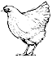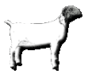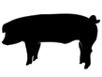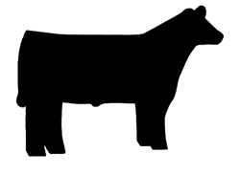
Thank You for your continued support of our program!

