2014-15 Royal FFA Livestock Show Commercial Heifer Certificate

Exhibitor’s name______________________________________________

Breeder’s Name _______________________________________________

Breeder’s address______________________________________________

Heifer’s date of birth (approximate) ________________________________

Breed(s) of Sire _______________________________________________

Breed(s) of Dam_______________________________________________

Student’s signature_____________________________________________

Breeder’s signature ________________________________________________
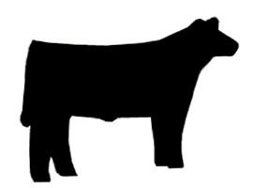

NOTE: To be eligible for competition at the 2015 show, steer & heifer projects must be born within the boundaries of

the Royal Independent School District.

